Natural Irregular Curved Shapes
# Source: AI Source: Provided by: [Data Path: Persons Table -> ID Column: 1, Name_En Column: Motasem Essam] -> From: [ChatGPT] on [7/25/2026]
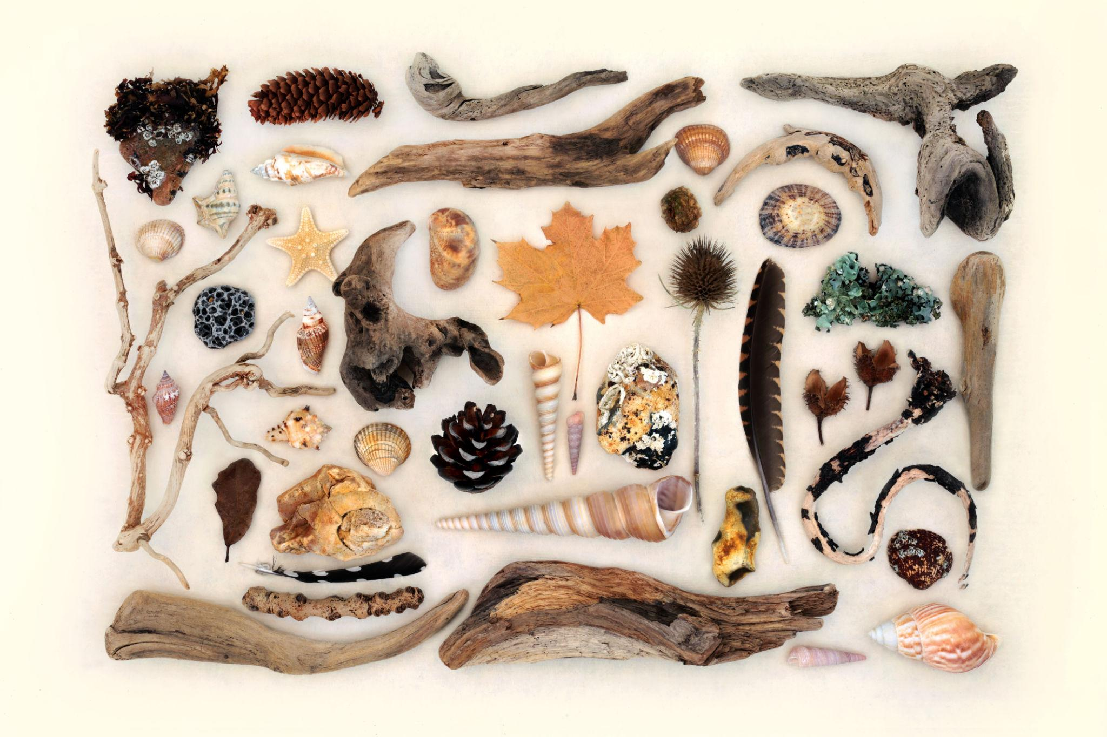
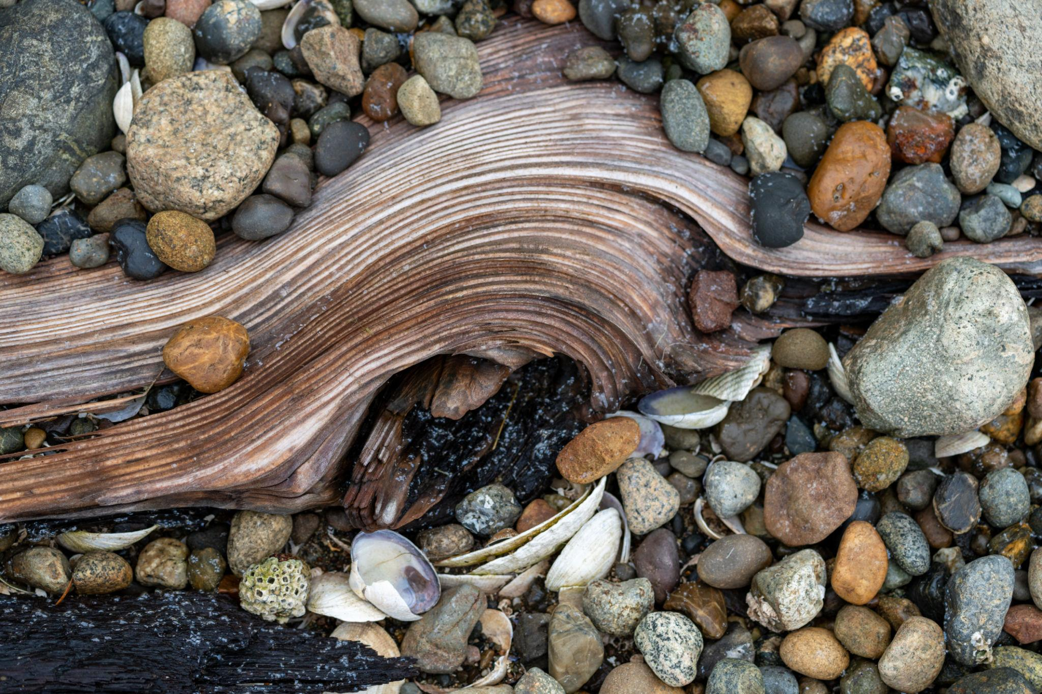
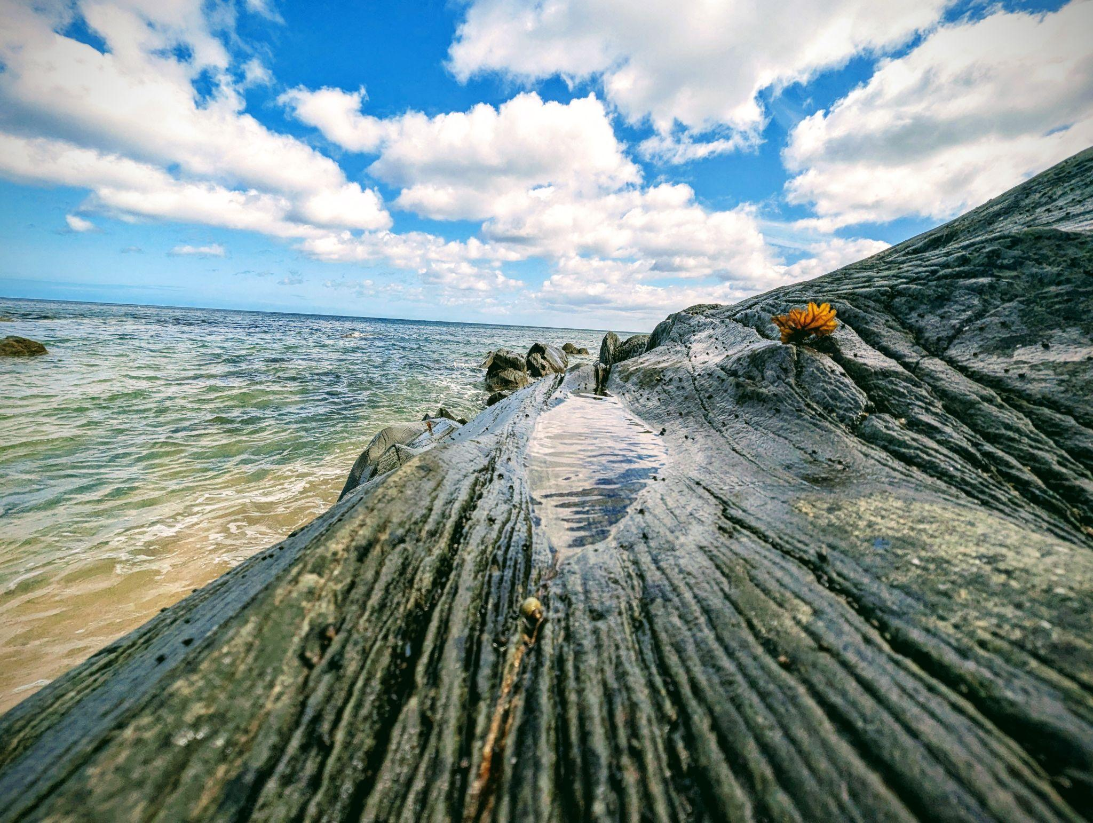
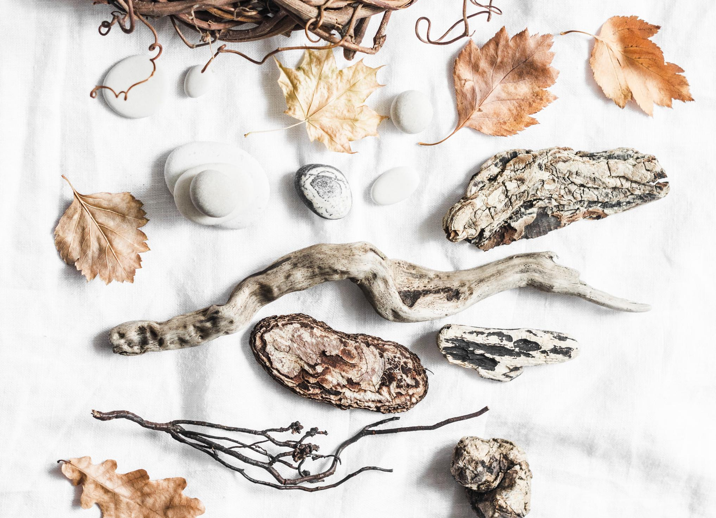
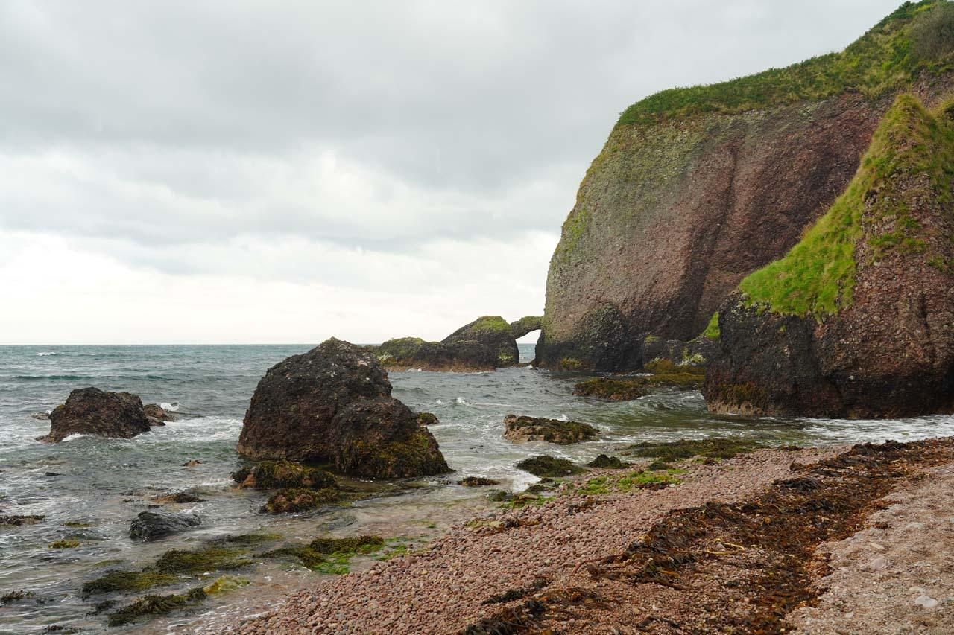
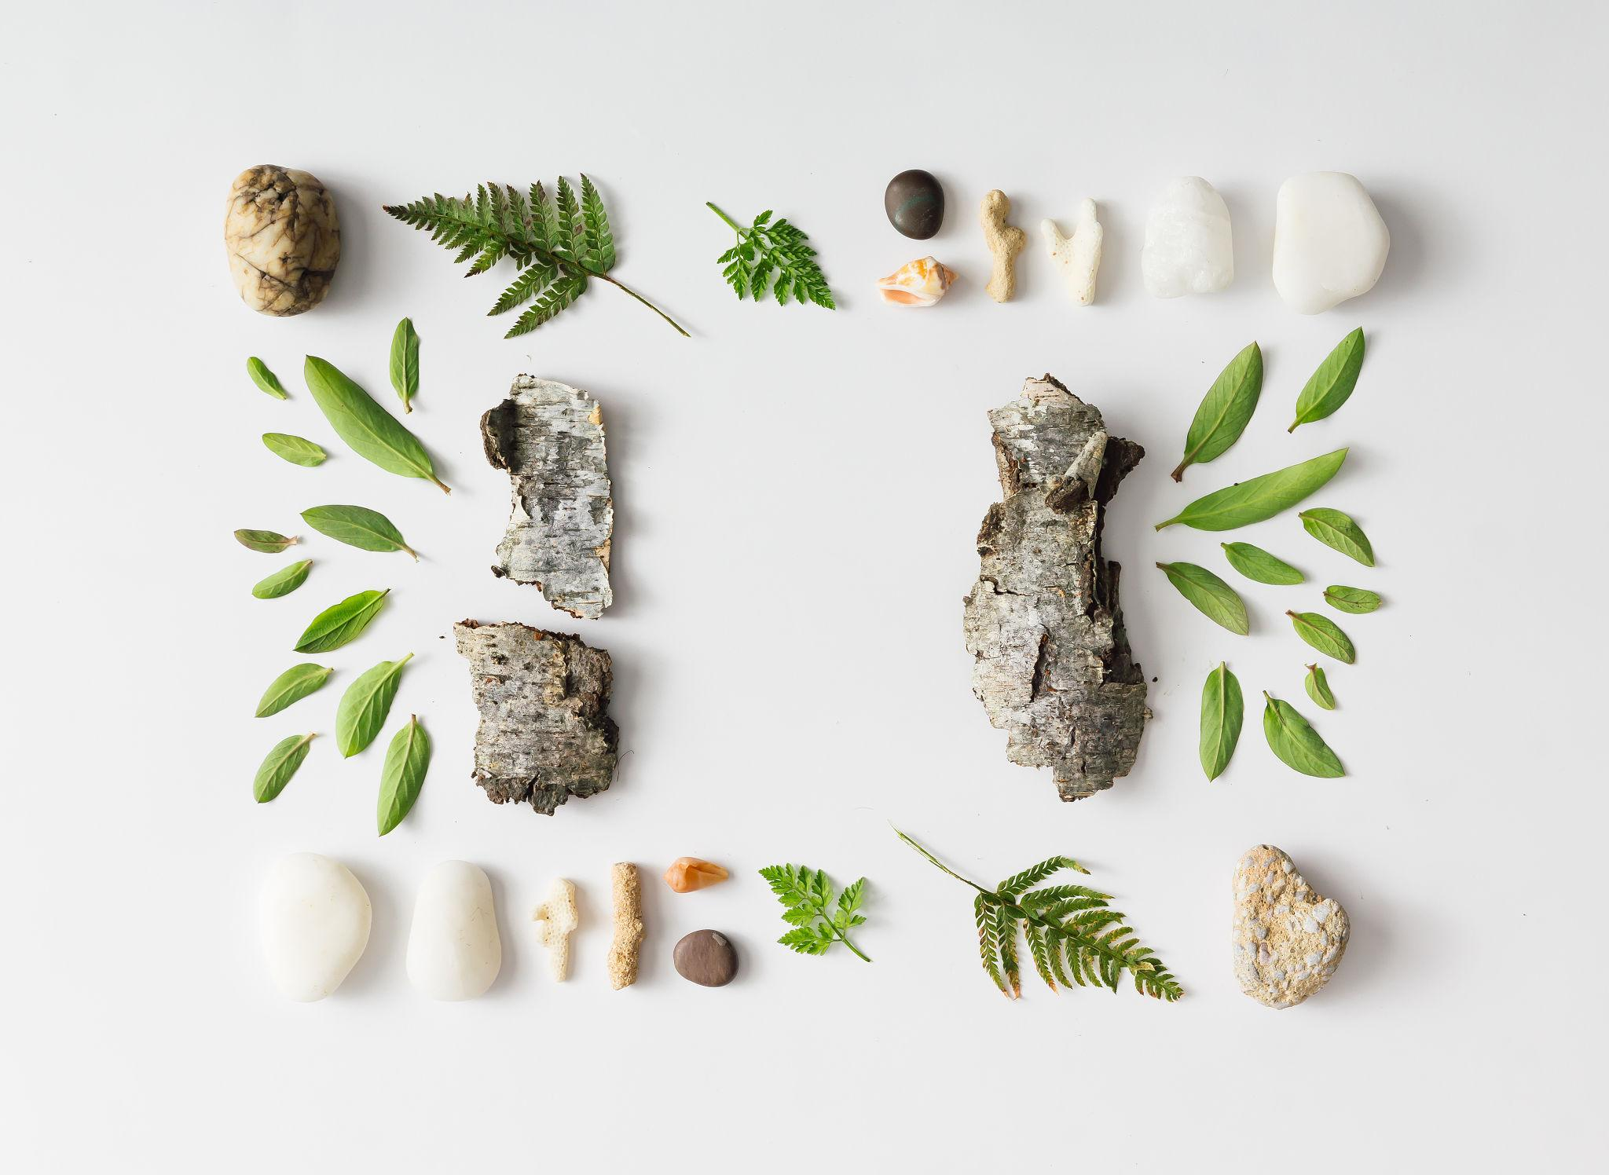

Definition
# Source: AI Source: Provided by: [Data Path: Persons Table -> ID Column: 1, Name_En Column: Motasem Essam] -> From: [ChatGPT] on [7/25/2026]
A Natural Irregular Curved Shape is an irregular shape found in nature whose boundary is primarily curved and does not follow a regular geometric form such as a circle, ellipse, or other standard geometric curve.
These shapes are produced by natural processes rather than being constructed according to exact geometric rules.
Examples include:
- Leaves
- Clouds
- Rocks
- Seashells
- Tree branches
- Coastlines
- Water pools

Characteristics
# Source: AI Source: Provided by: [Data Path: Persons Table -> ID Column: 1, Name_En Column: Motasem Essam] -> From: [ChatGPT] on [7/25/2026]
A natural irregular curved shape typically:
- Has a curved boundary.
- Does not have uniform dimensions.
- Has variable curvature.
- Does not necessarily have a simple mathematical equation.
- Usually lacks perfect symmetry.
- May have smooth or rough sections.
- Can vary significantly between individual examples.
- Is formed by natural processes.

Examples

1. Leaves
# Source: AI Source: Provided by: [Data Path: Persons Table -> ID Column: 1, Name_En Column: Motasem Essam] -> From: [ChatGPT] on [7/25/2026]
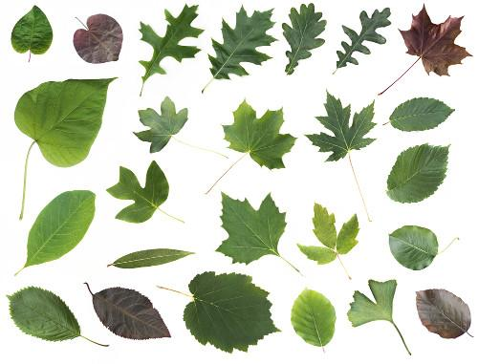
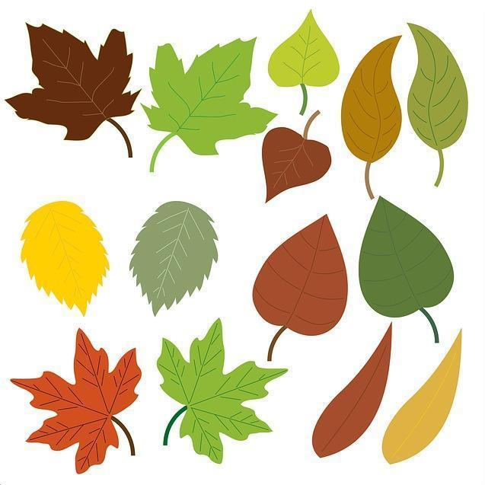
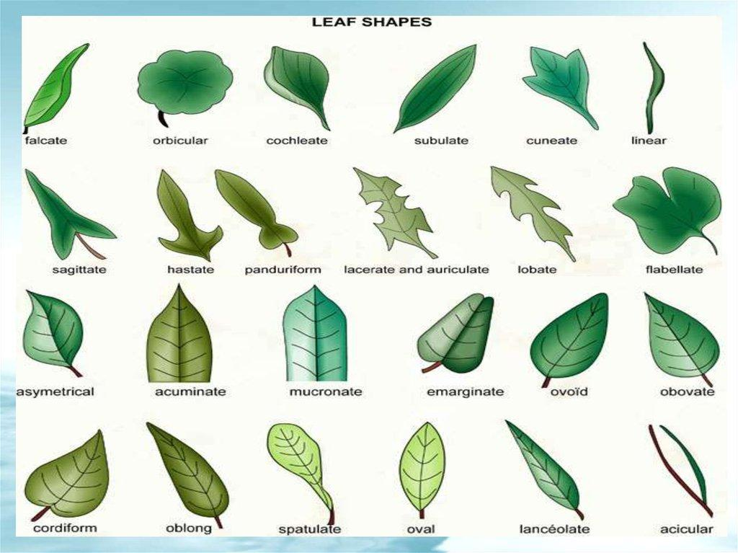
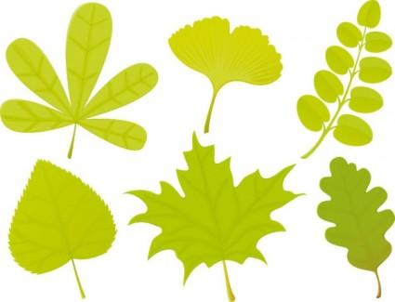
Leaves often have curved and asymmetric boundaries.
Examples include:
- Oak leaves.
- Maple leaves.
- Fig leaves.
- Ivy leaves.

2. Clouds
# Source: AI Source: Provided by: [Data Path: Persons Table -> ID Column: 1, Name_En Column: Motasem Essam] -> From: [ChatGPT] on [7/25/2026]
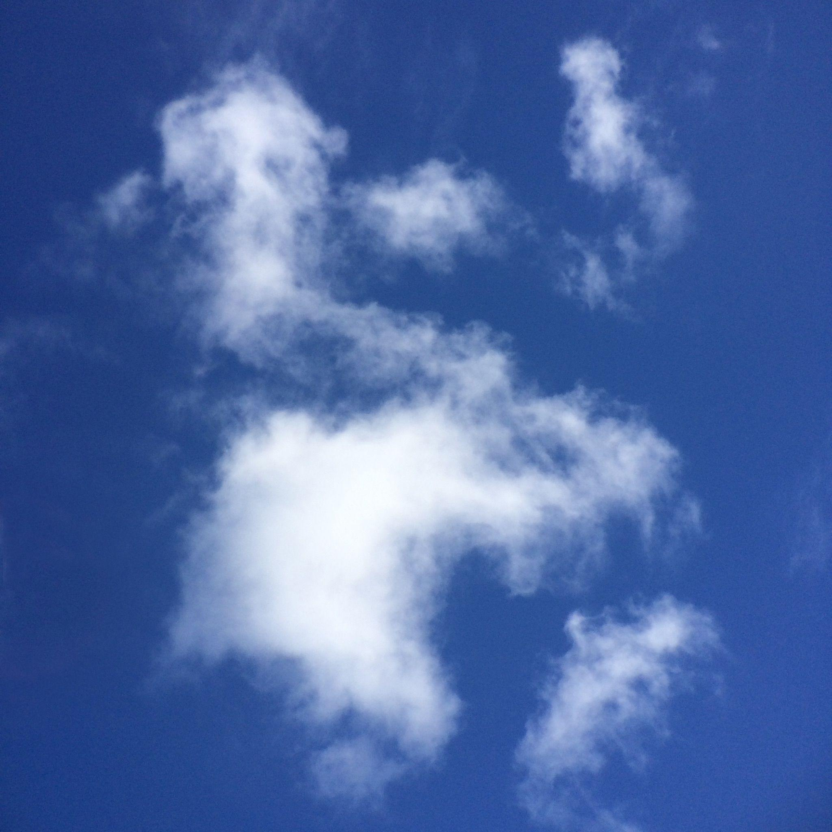
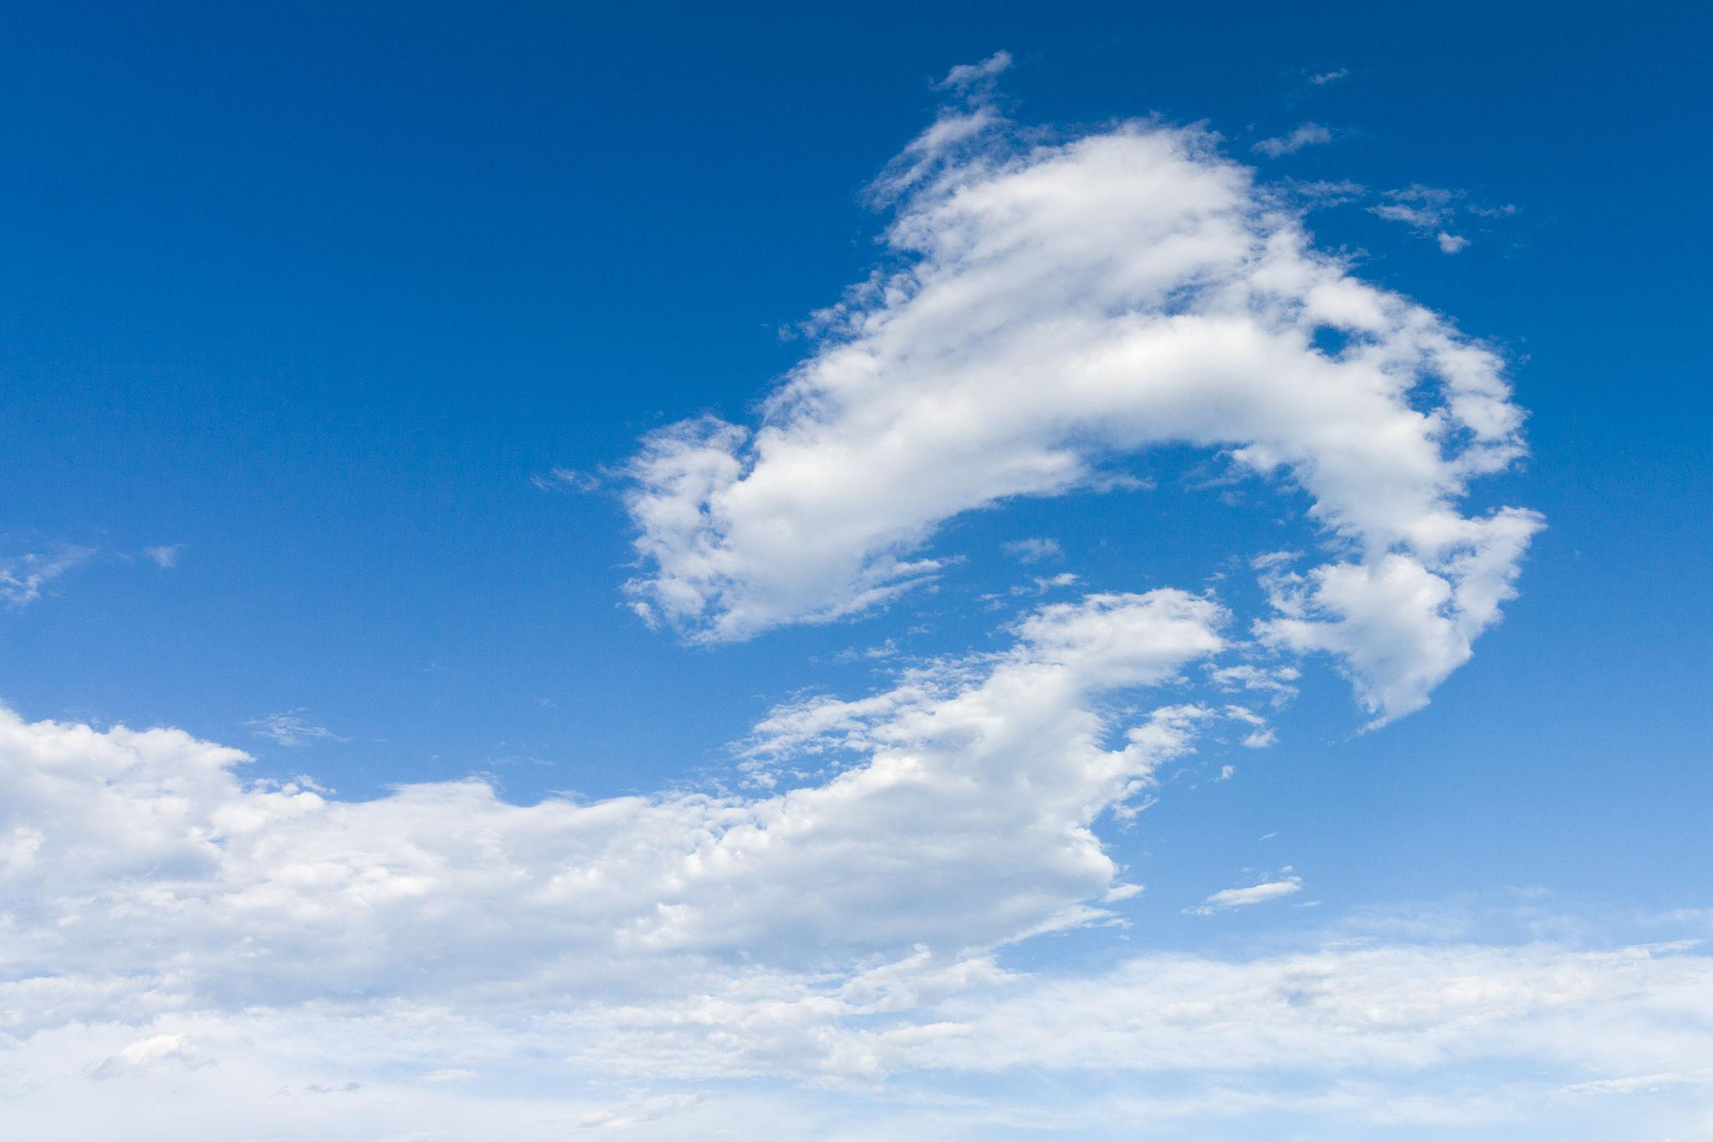
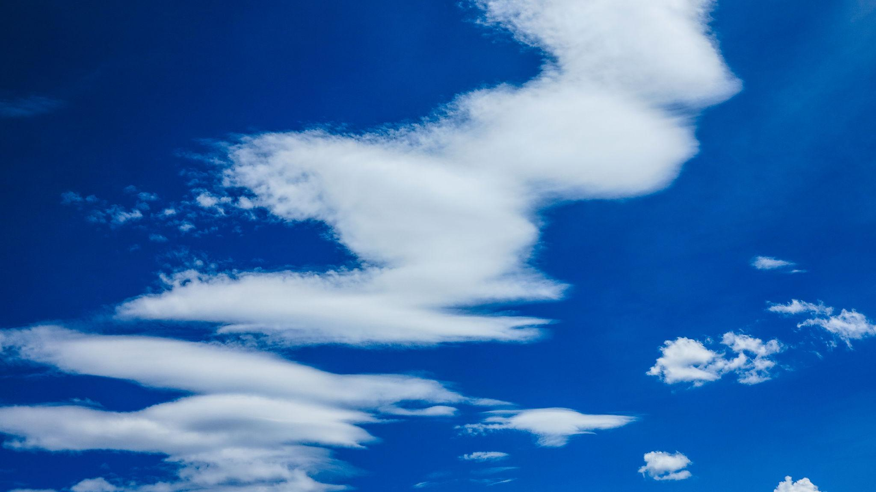
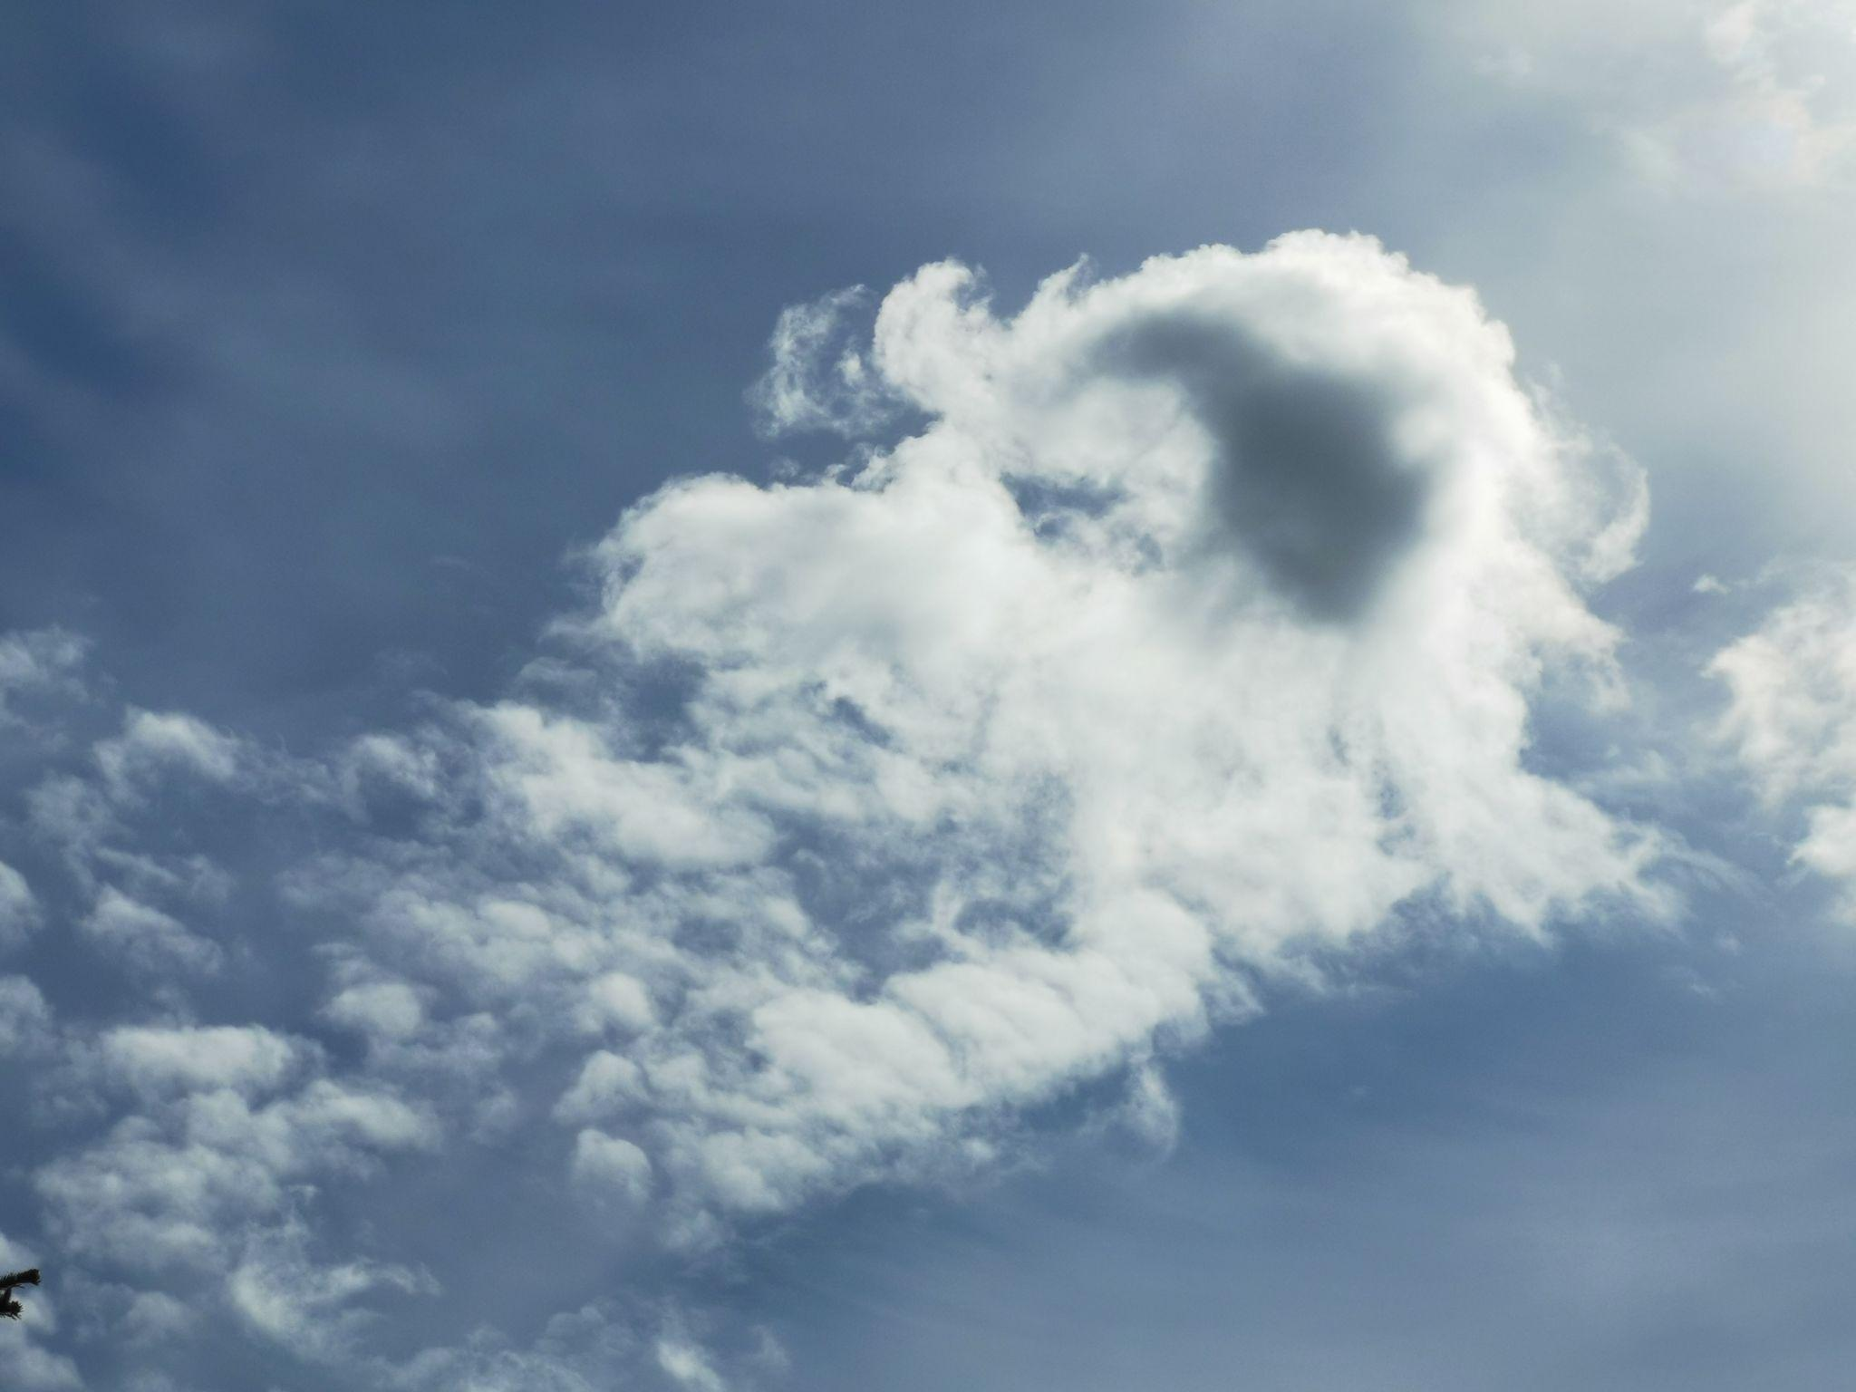
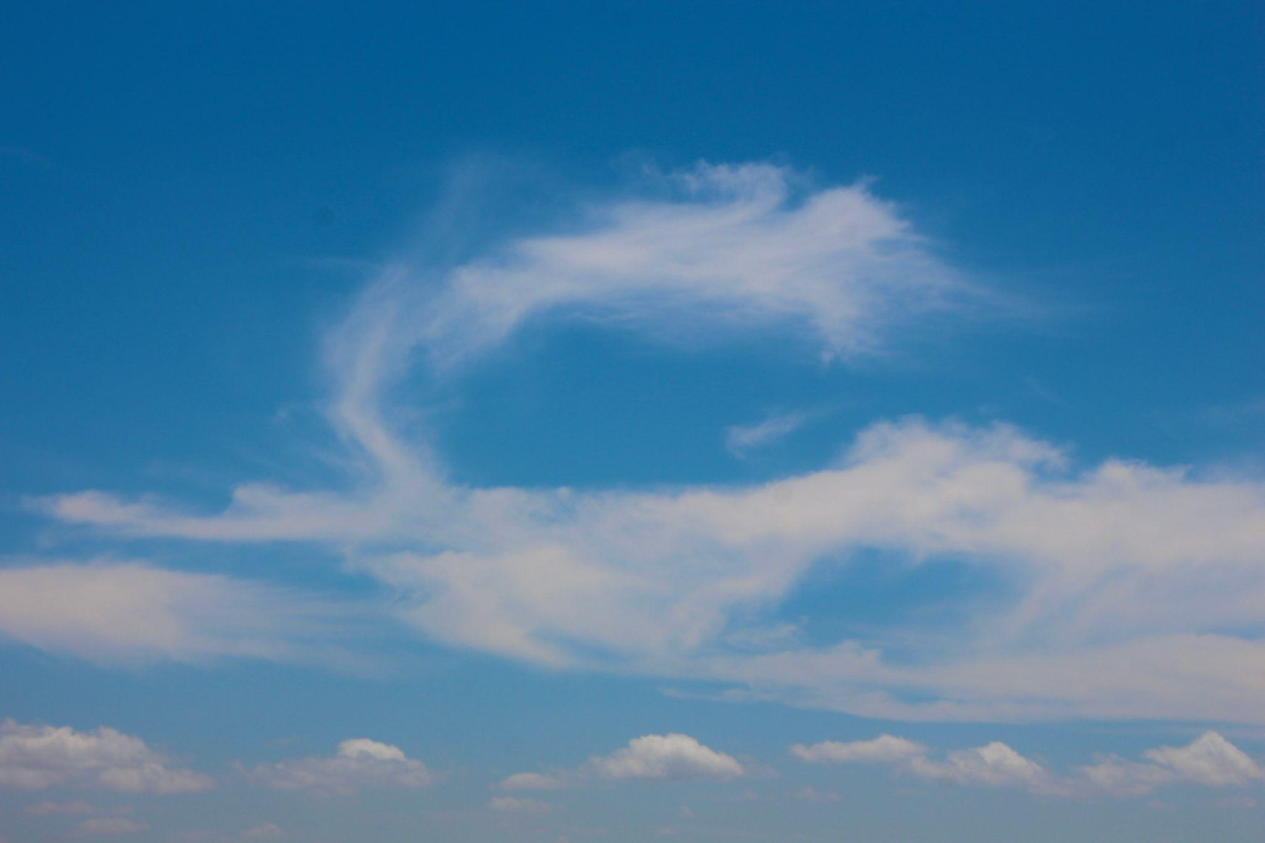
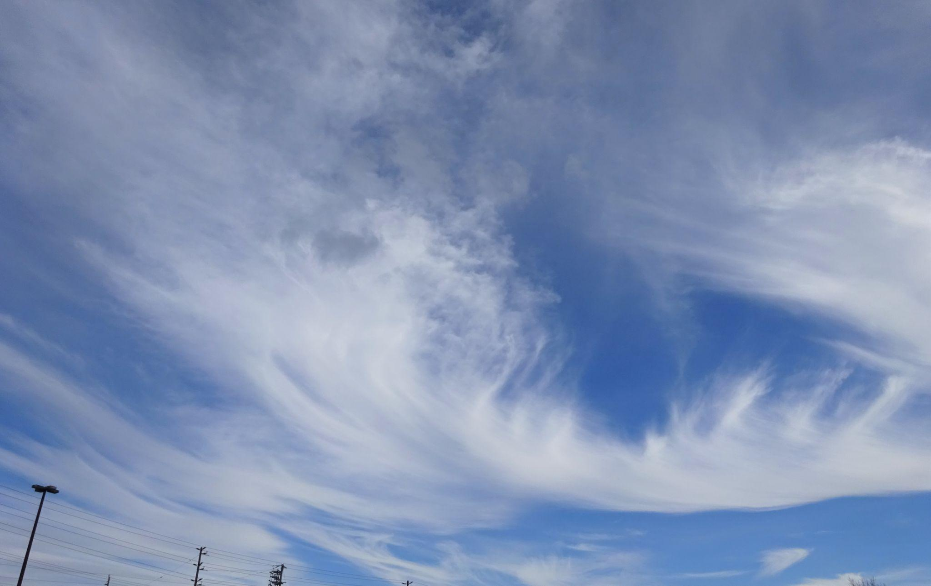
Clouds have continuously changing curved boundaries and generally do not have a fixed geometric shape.

3. Rocks
# Source: AI Source: Provided by: [Data Path: Persons Table -> ID Column: 1, Name_En Column: Motasem Essam] -> From: [ChatGPT] on [7/25/2026]
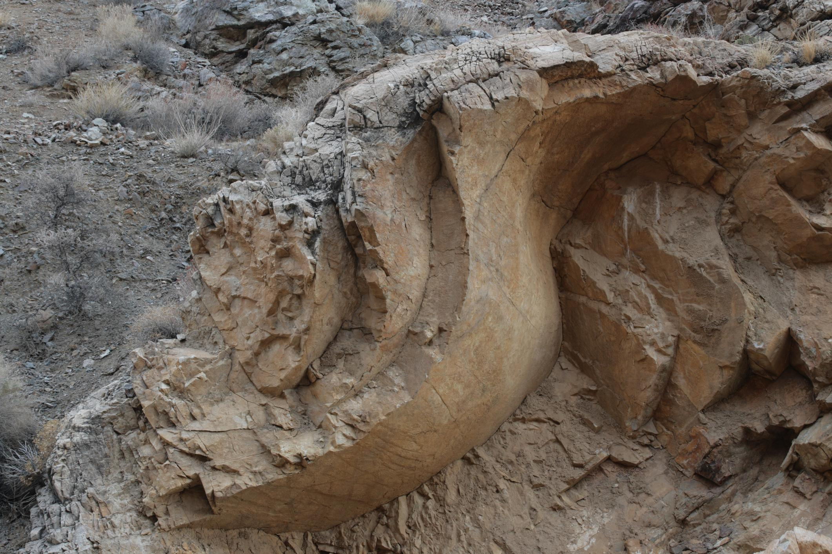
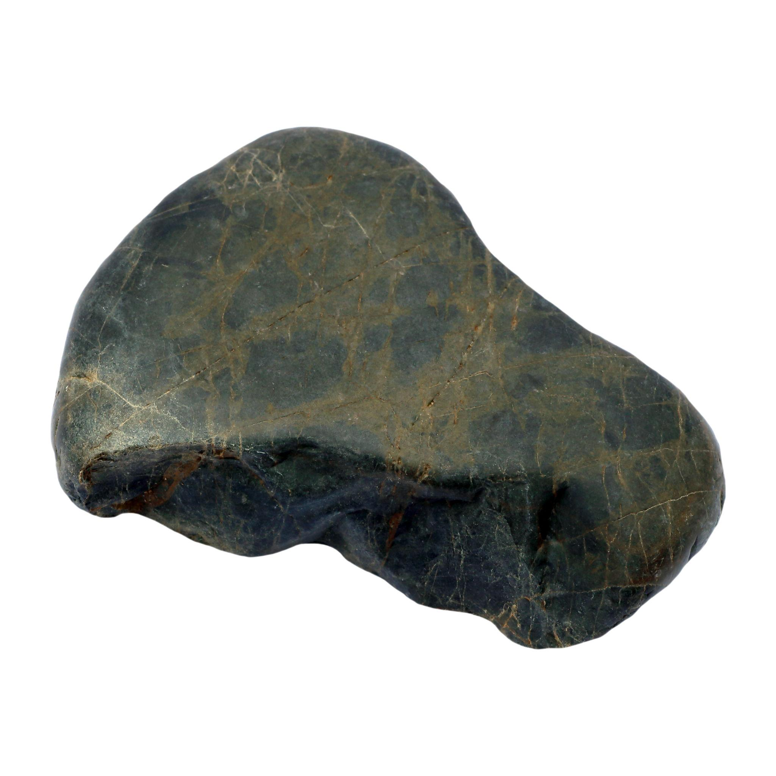
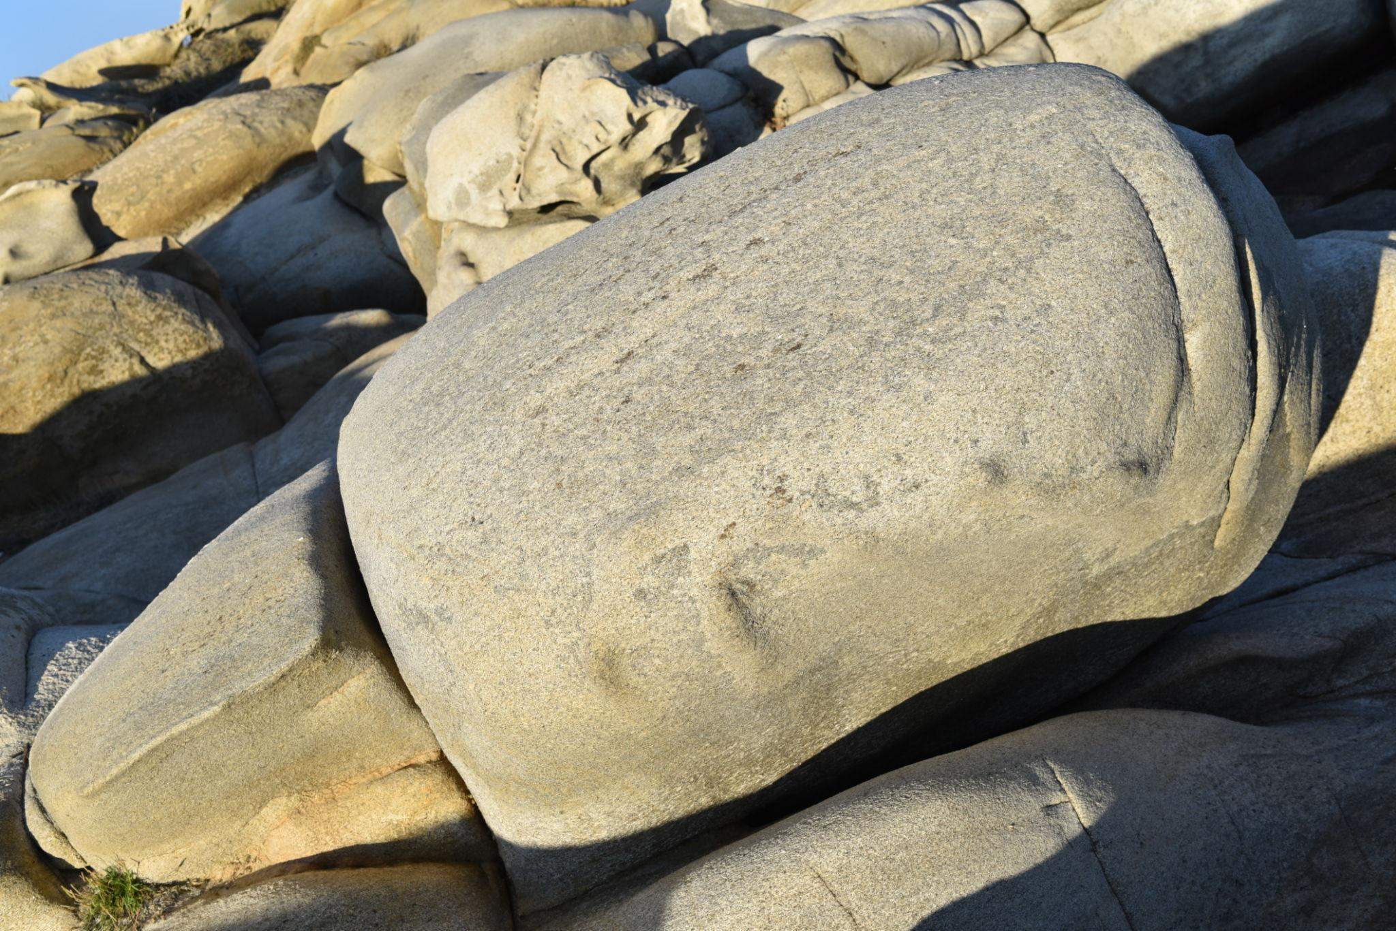
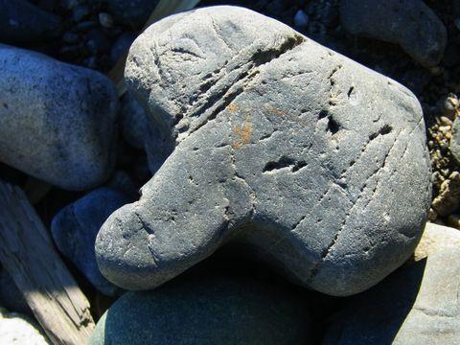
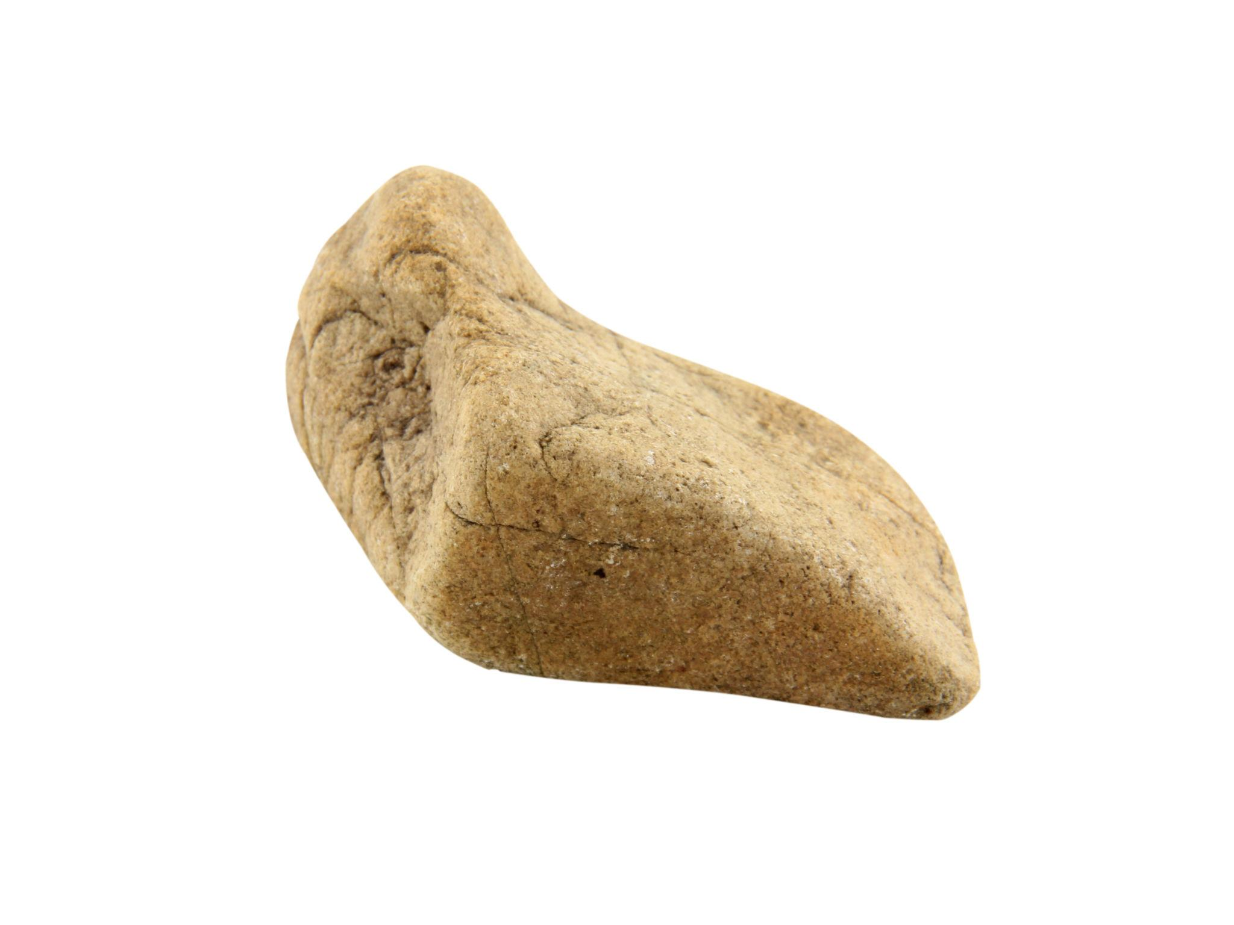
Natural rocks often have uneven, curved boundaries produced by:
- Erosion.
- Weathering.
- Geological processes.

4. Seashells
# Source: AI Source: Provided by: [Data Path: Persons Table -> ID Column: 1, Name_En Column: Motasem Essam] -> From: [ChatGPT] on [7/25/2026]
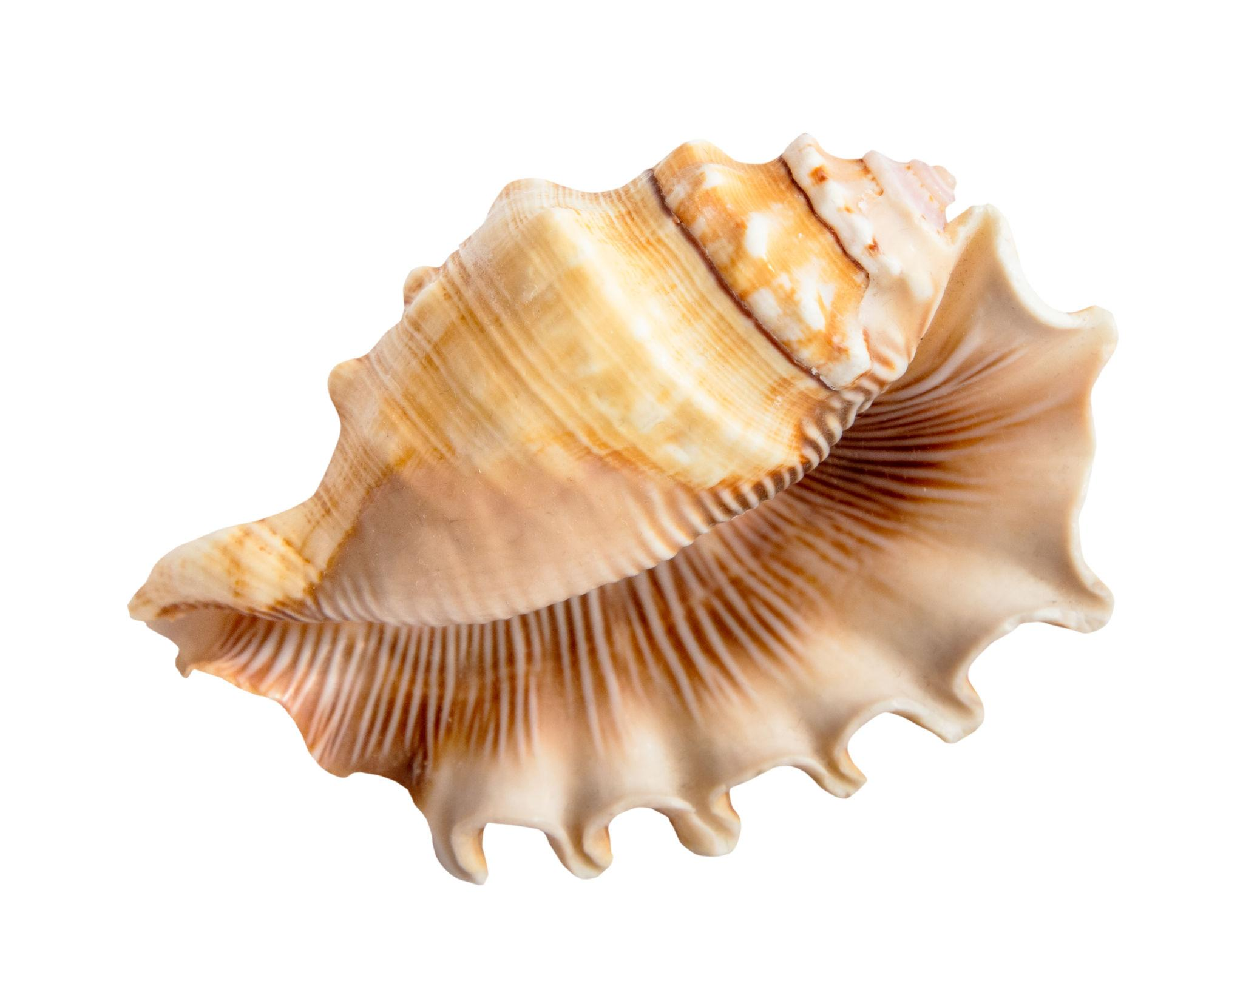
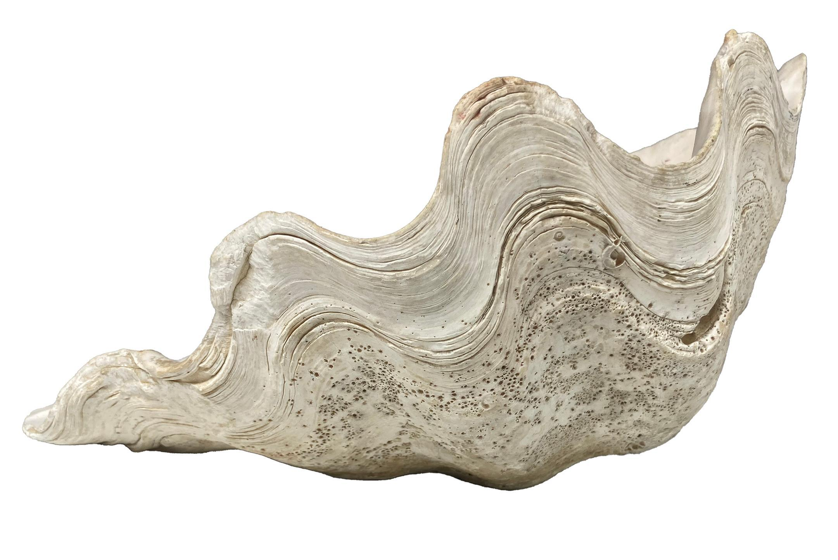
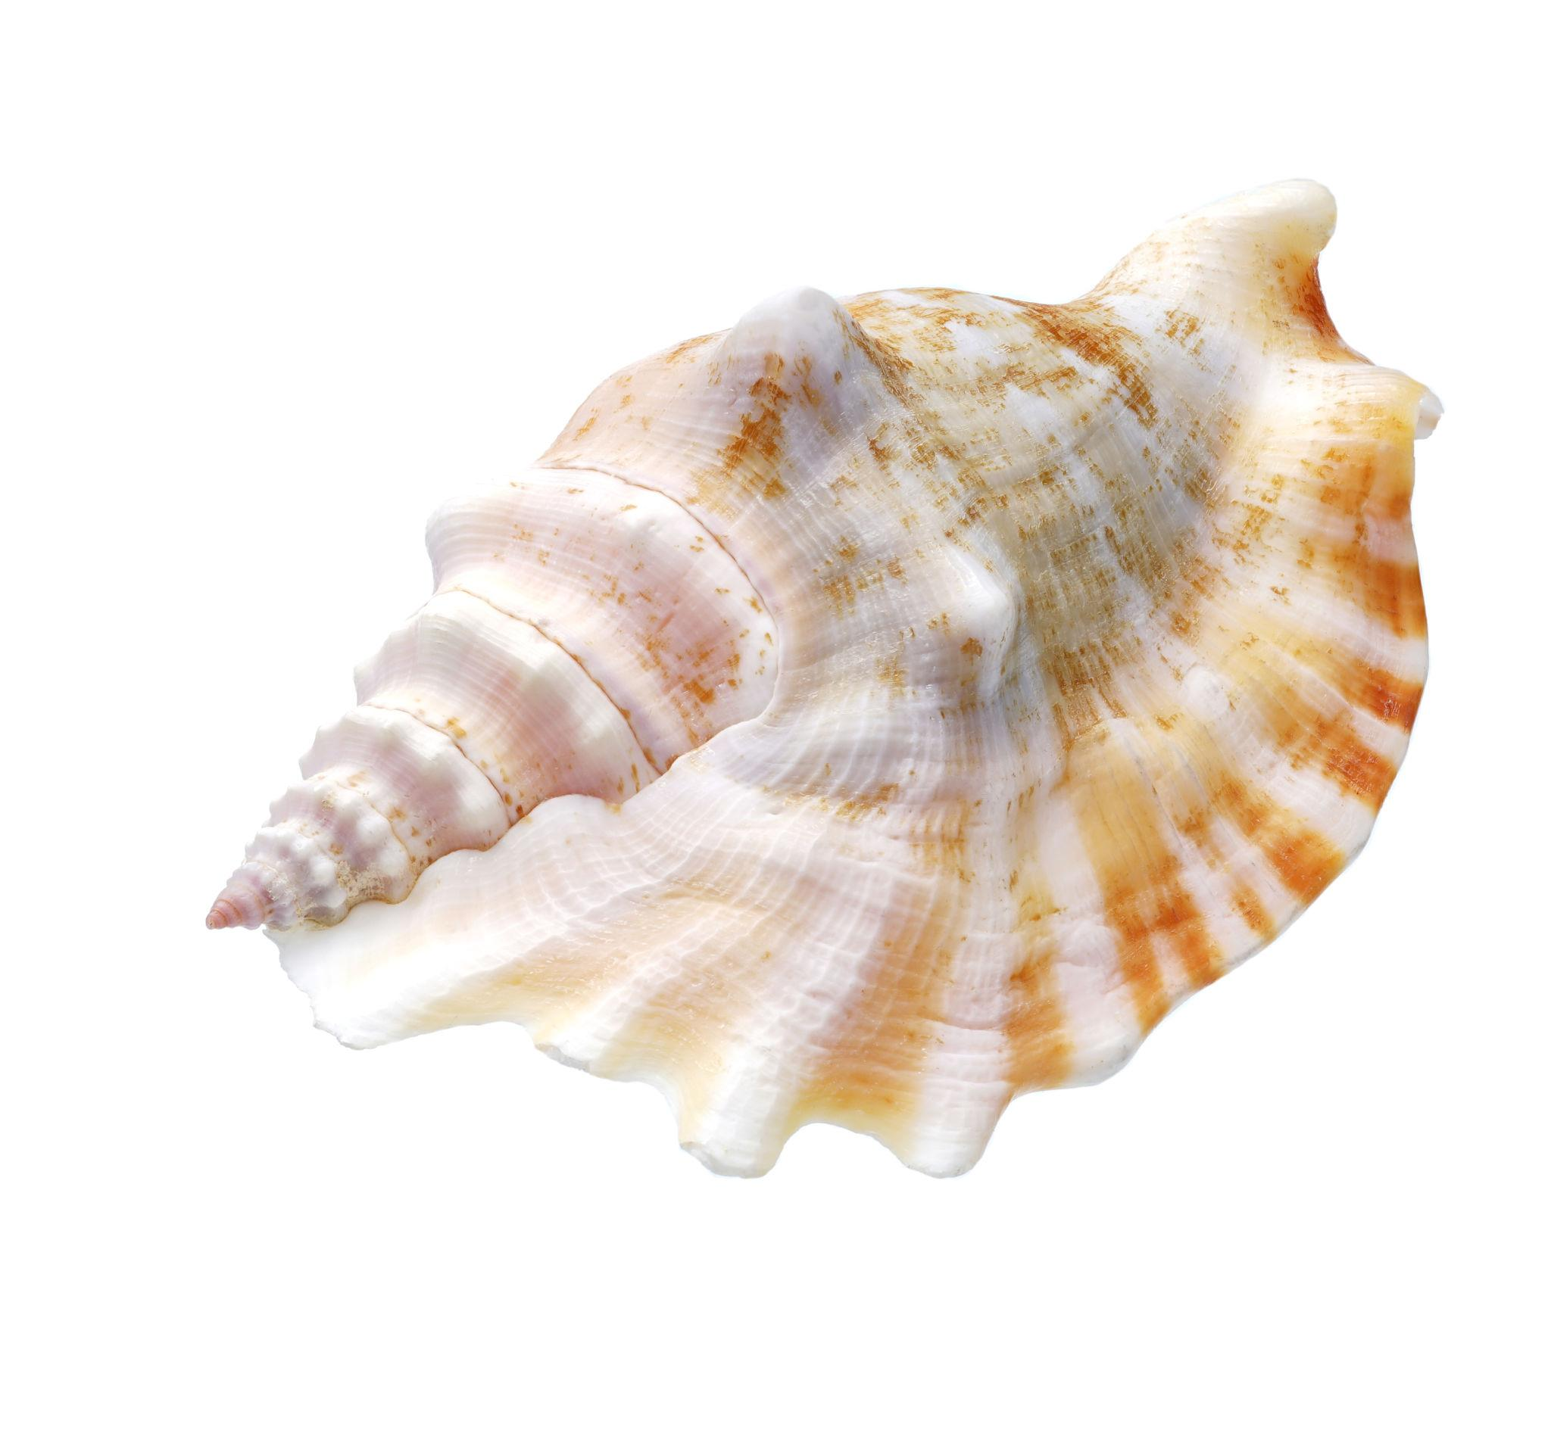
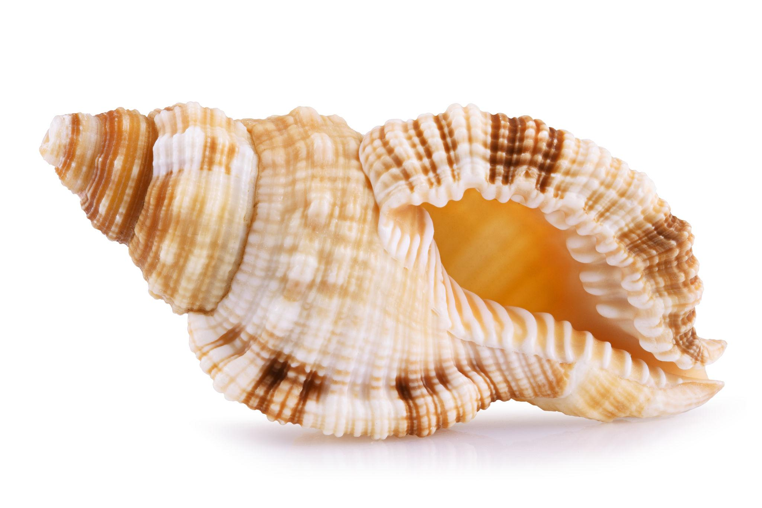
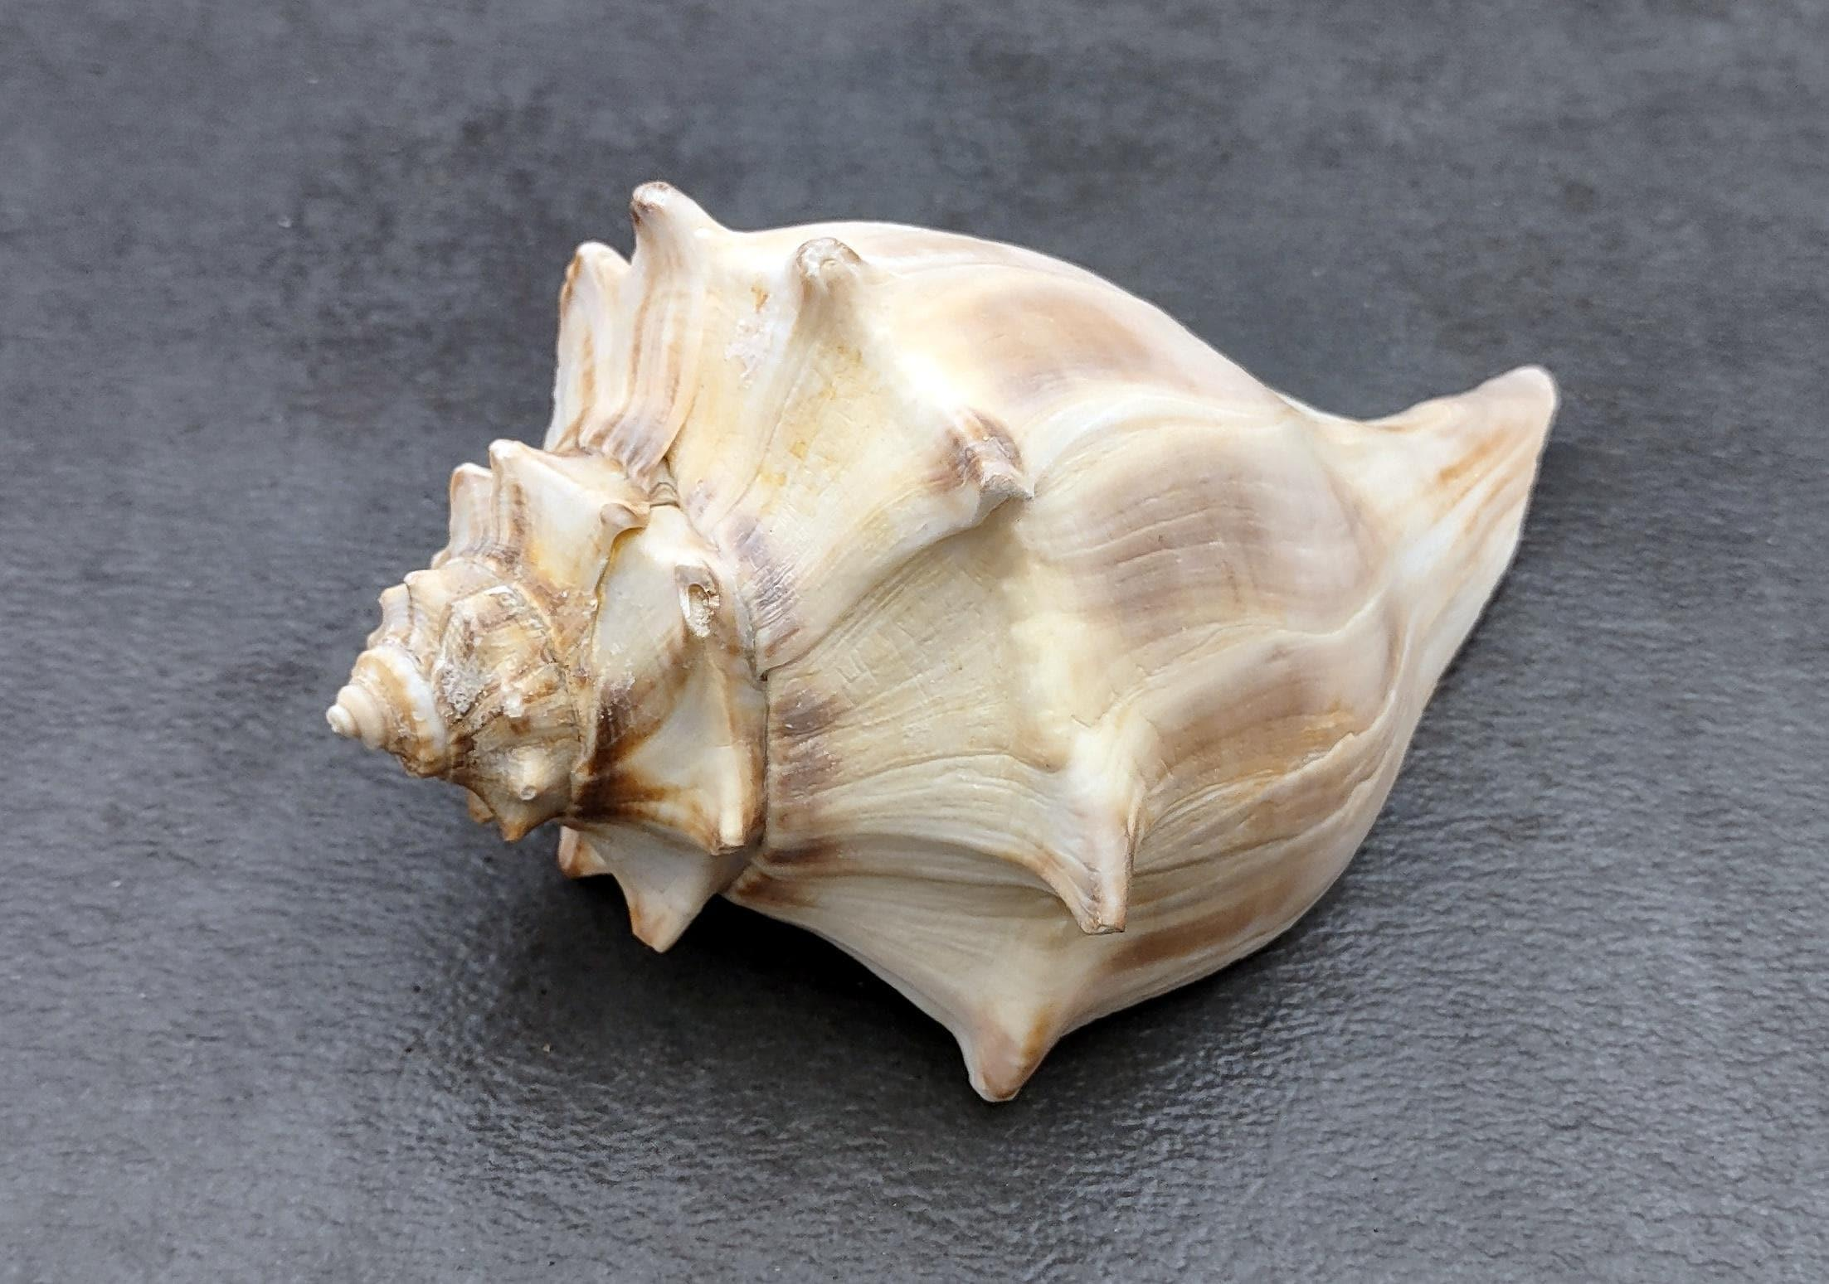
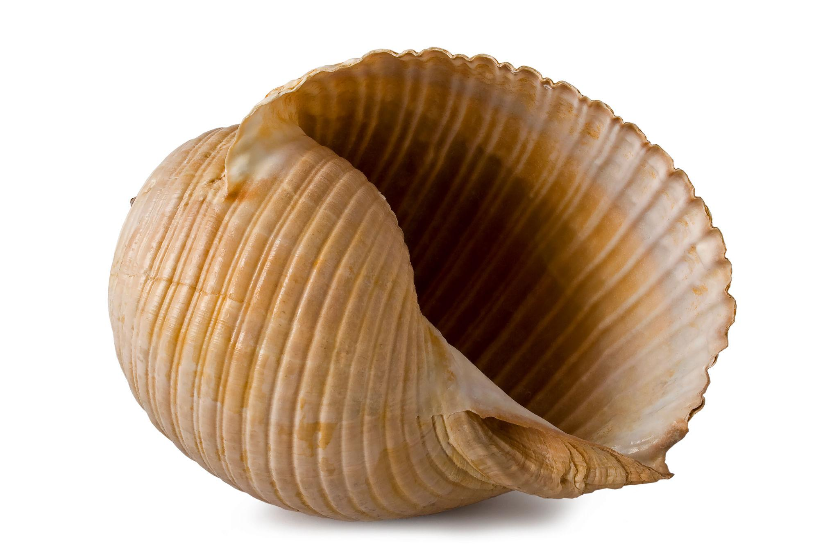
Some seashells have complex curved surfaces and boundaries that cannot be represented accurately by a simple circle or ellipse.

5. Tree Branches
# Source: AI Source: Provided by: [Data Path: Persons Table -> ID Column: 1, Name_En Column: Motasem Essam] -> From: [ChatGPT] on [7/25/2026]
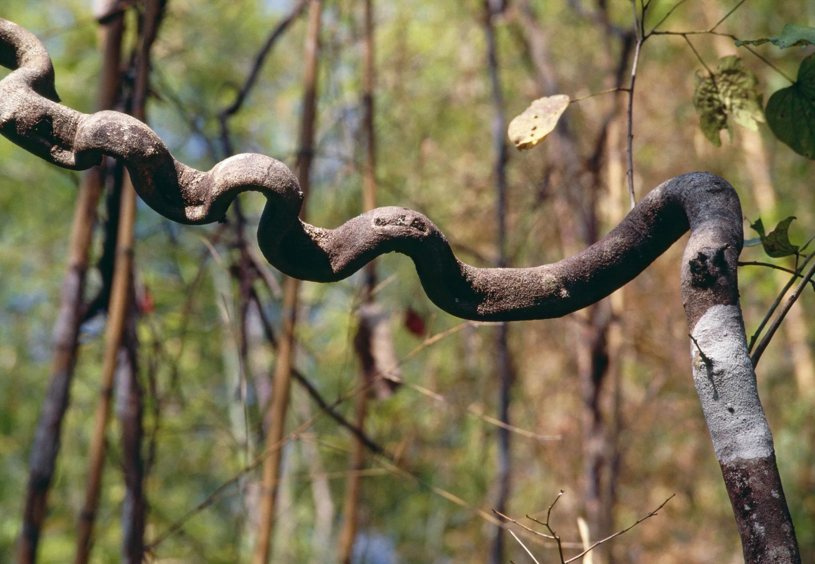
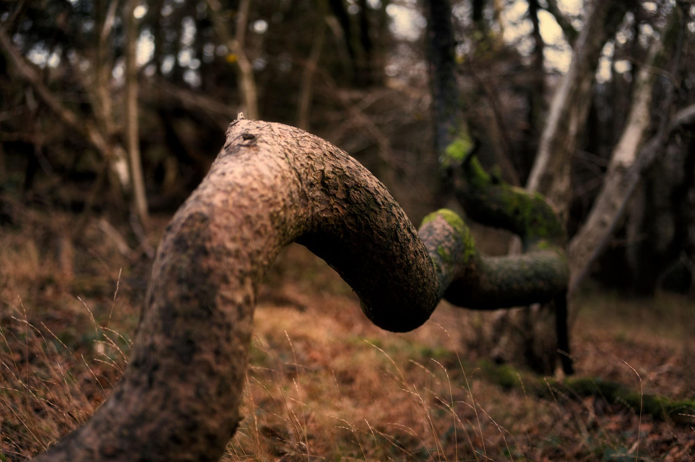
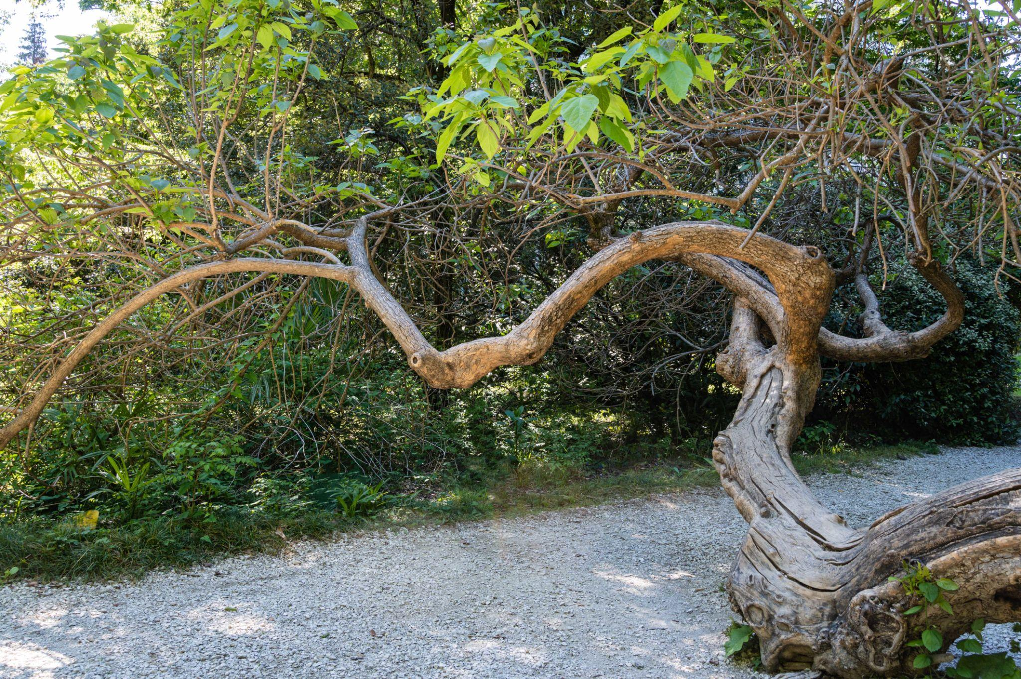
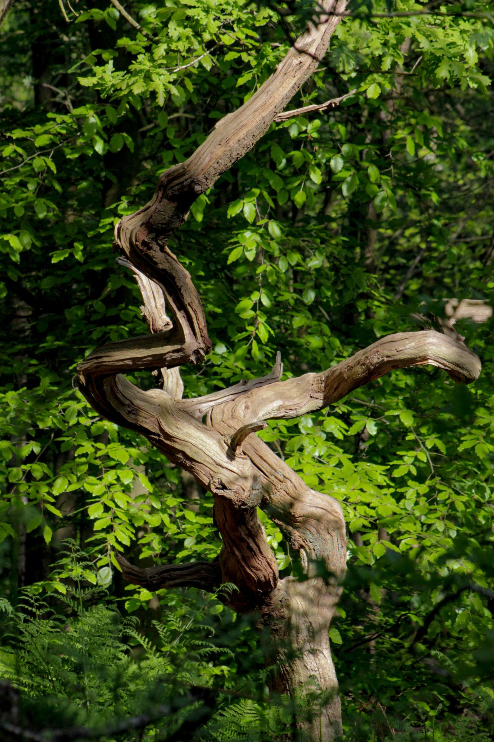
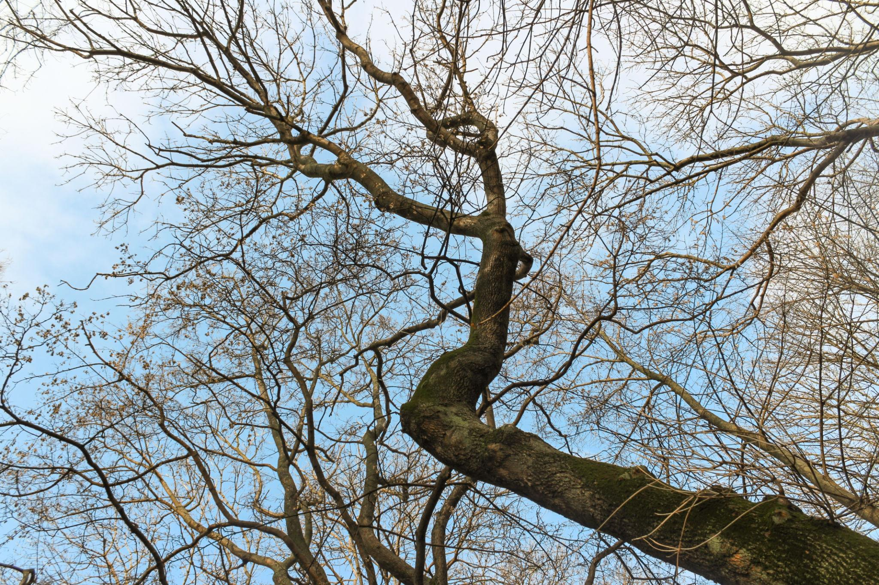
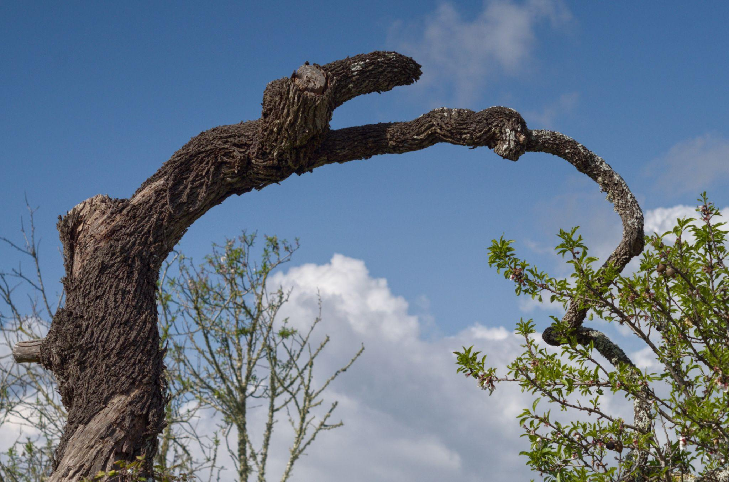
Branches form irregular curved paths as they grow toward light and respond to environmental conditions.

6. Coastlines
# Source: AI Source: Provided by: [Data Path: Persons Table -> ID Column: 1, Name_En Column: Motasem Essam] -> From: [ChatGPT] on [7/25/2026]
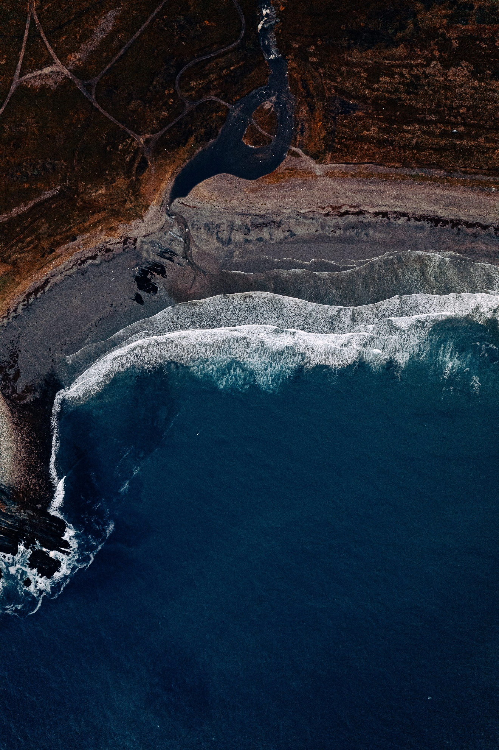
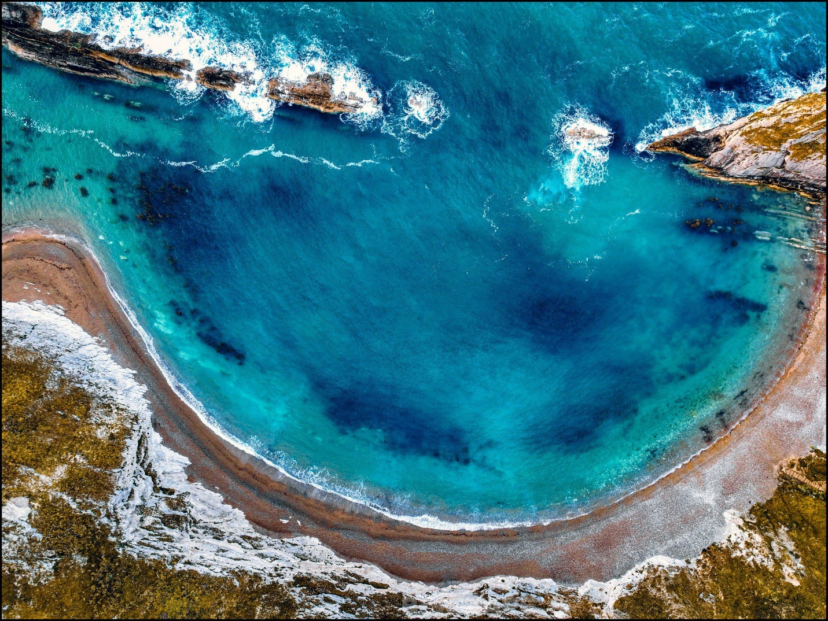
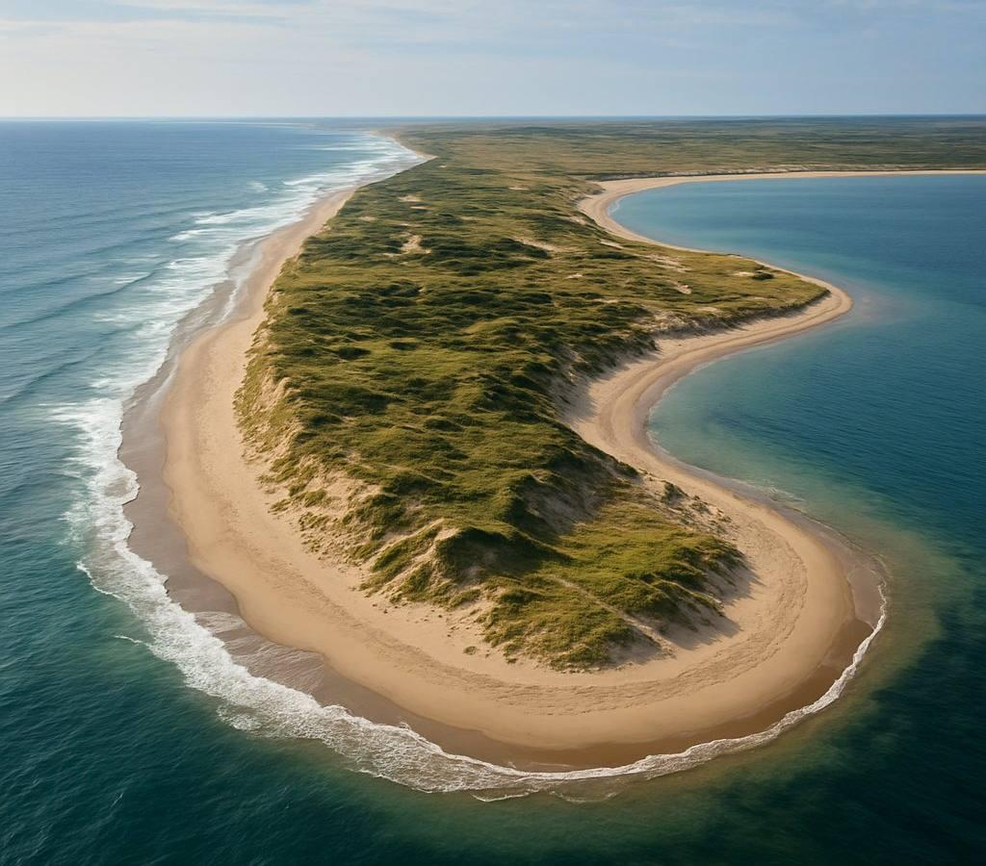
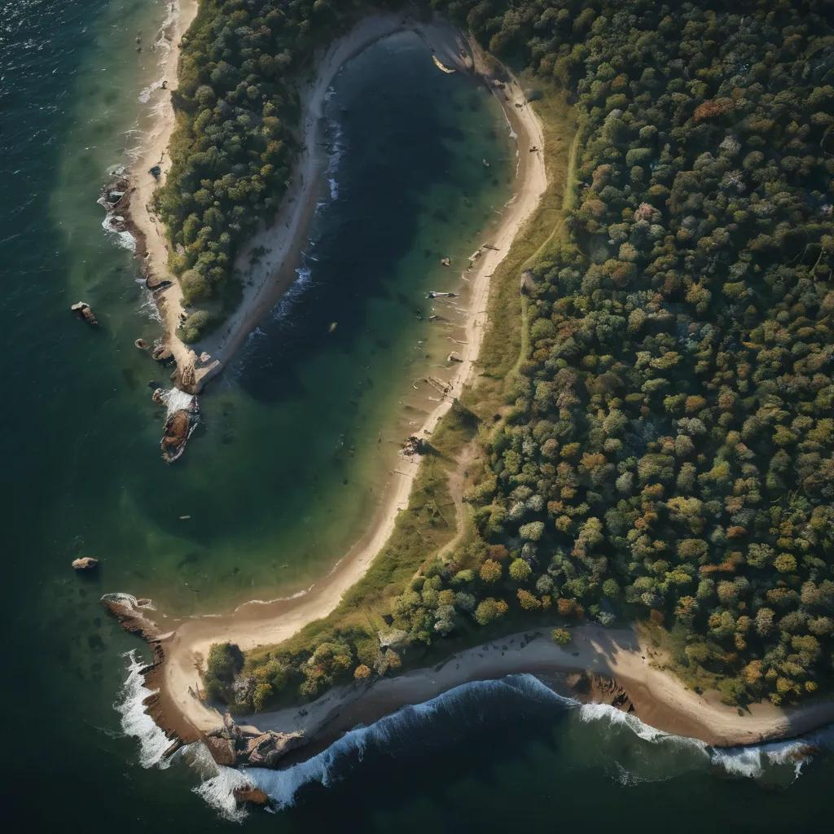
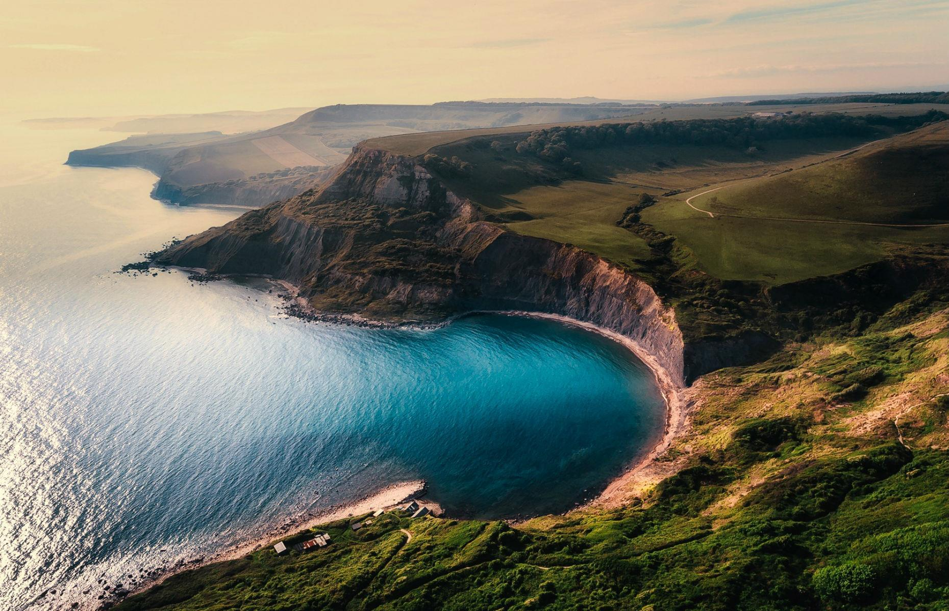
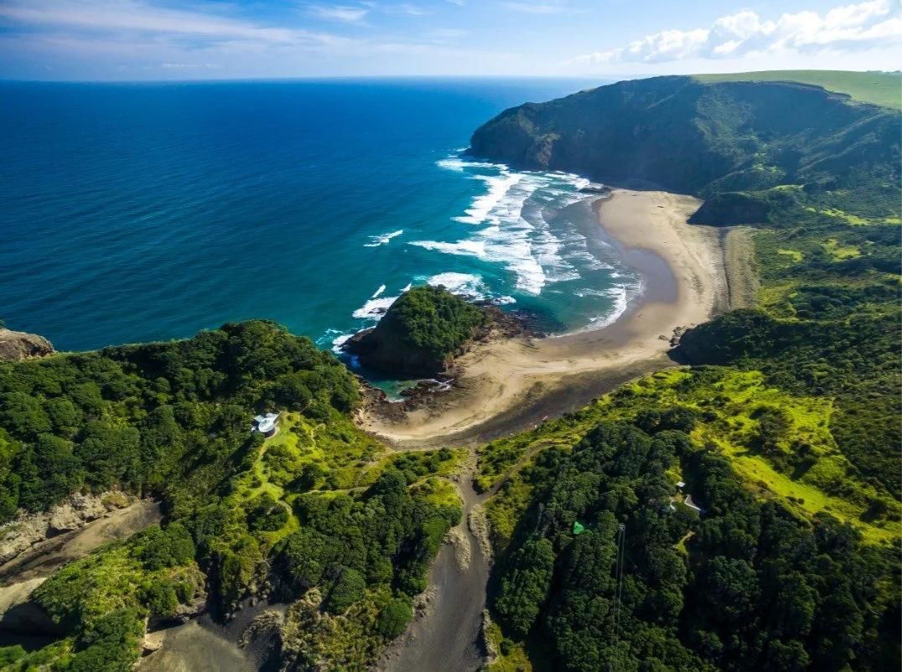
Coastlines are examples of highly irregular natural curved boundaries produced by:
- Waves.
- Tides.
- Erosion.
- Sedimentation.

Mathematical Representation
# Source: AI Source: Provided by: [Data Path: Persons Table -> ID Column: 1, Name_En Column: Motasem Essam] -> From: [ChatGPT] on [7/25/2026]
Natural irregular curved shapes usually cannot be represented by a single simple equation.
They may instead be approximated using:
Parametric Curves
$$x=f\left(t\right), y=g\left(t\right)$$
Splines
$$C\left(t\right)=\sum_{i}{N_{i}}\left(t\right)P_{i}$$
Numerical Methods
Measurements such as area and perimeter can be estimated using numerical techniques or digital image analysis.

Area
# Source: AI Source: Provided by: [Data Path: Persons Table -> ID Column: 1, Name_En Column: Motasem Essam] -> From: [ChatGPT] on [7/25/2026]
For a closed natural irregular curved shape, the area can be estimated using:
Grid Approximation
$$A≈\text{number of covered unit squares}$$
Coordinate Methods
If the boundary is represented mathematically, numerical integration can be used:
$$A=\int_{a}^{b}{f}\left(x\right),dx$$
For complex digital boundaries, computational geometry algorithms can calculate or approximate the enclosed area.

Boundary
# Source: AI Source: Provided by: [Data Path: Persons Table -> ID Column: 1, Name_En Column: Motasem Essam] -> From: [ChatGPT] on [7/25/2026]
The boundary of a natural irregular curved shape is generally:
$$\boxed{\text{Curved + Irregular}}$$
For example, a leaf has a continuous curved boundary:
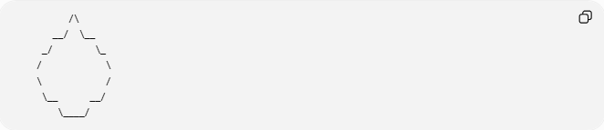
/\
__/ \__
_/ \_
/ \
\ /
\__ __/
\____/
The exact boundary depends on the particular leaf.

Natural vs. Artificial Irregular Curved Shapes
# Source: AI Source: Provided by: [Data Path: Persons Table -> ID Column: 1, Name_En Column: Motasem Essam] -> From: [ChatGPT] on [7/25/2026]
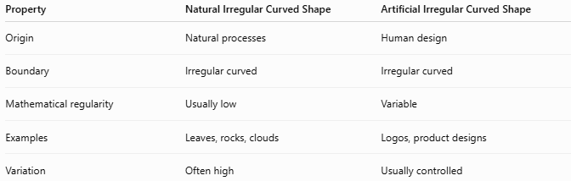
Property | Natural Irregular Curved Shape | Artificial Irregular Curved Shape
Origin | Natural processes | Human design
Boundary | Irregular curved | Irregular curved
Mathematical regularity | Usually low | Variable
Examples | Leaves, rocks, clouds | Logos, product designs
Variation | Often high | Usually controlled

Natural Irregular Curved vs. Regular Curved Shapes
# Source: AI Source: Provided by: [Data Path: Persons Table -> ID Column: 1, Name_En Column: Motasem Essam] -> From: [ChatGPT] on [7/25/2026]
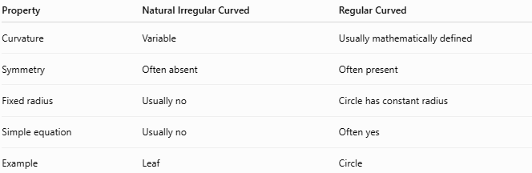
Property | Natural Irregular Curved | Regular Curved
Curvature | Variable | Usually mathematically defined
Symmetry | Often absent | Often present
Fixed radius | Usually no | Circle has constant radius
Simple equation | Usually no | Often yes
Example | Leaf | Circle

Natural Irregular Curved vs. Irregular Polygonal
# Source: AI Source: Provided by: [Data Path: Persons Table -> ID Column: 1, Name_En Column: Motasem Essam] -> From: [ChatGPT] on [7/25/2026]
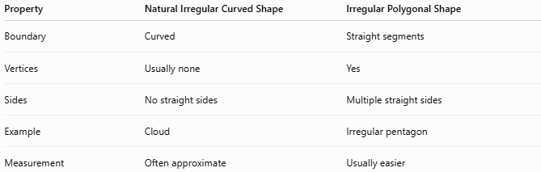
Property | Natural Irregular Curved Shape | Irregular Polygonal Shape
Boundary | Curved | Straight segments
Vertices | Usually none | Yes
Sides | No straight sides | Multiple straight sides
Example | Cloud | Irregular pentagon
Measurement | Often approximate | Usually easier

Applications
# Source: AI Source: Provided by: [Data Path: Persons Table -> ID Column: 1, Name_En Column: Motasem Essam] -> From: [ChatGPT] on [7/25/2026]
Natural irregular curved shapes are studied and modeled in:
- Geometry
- Biology
- Botany
- Geography
- Geology
- Environmental Science
- GIS
- Computer Graphics
- Image Processing
- Architecture
- Engineering

Key Points
# Source: AI Source: Provided by: [Data Path: Persons Table -> ID Column: 1, Name_En Column: Motasem Essam] -> From: [ChatGPT] on [7/25/2026]
A Natural Irregular Curved Shape:
$$\boxed{\text{Natural origin}+\text{Irregular form}+\text{Curved boundary}}$$
Common examples include:
- 🍃 Leaves
- ☁️ Clouds
- 🪨 Rocks
- 🐚 Seashells
- 🌳 Tree branches
- 🌊 Coastlines
They generally have variable curvature, irregular dimensions, and no simple standard geometric equation.

Conclusion
# Source: AI Source: Provided by: [Data Path: Persons Table -> ID Column: 1, Name_En Column: Motasem Essam] -> From: [ChatGPT] on [7/25/2026]
Natural Irregular Curved Shapes are curved, non-uniform forms created by natural processes. They are different from standard geometric shapes because their boundaries and dimensions vary naturally. Leaves, clouds, rocks, shells, branches, and coastlines are common examples, making this category particularly useful for connecting plane geometry with biology, geography, geology, environmental science, GIS, and computational modeling.

